Sort command is used to view the content of a file in an order

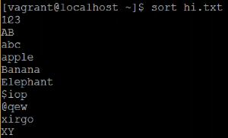

If we want to view in reverse order, then use -r as below

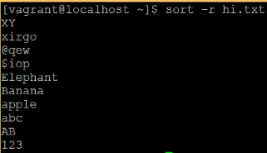

* **Netstat -nl 🡪 to see all the ports on server**
* **Netstat -nl | grep 23 🡪 to filter**
* If we want to check the port on remote machine, then we can use telnet. In some machines telnet might not get installed. We can install manually as below
* **Sudo yum install telnet 🡪 sudo is used here to install the software with root privileges**

File Permissions:

